***Forming Differential Equation***

**Find the D.E. of all parabolas whose axes are parallel to the axis of Y.**

{"mathml":"<math style=\"font-family:stix;font-size:16px;\" xmlns=\"http://www.w3.org/1998/Math/MathML\"><msup><mfenced><mrow><mi>x</mi><mo>-</mo><mi>h</mi></mrow></mfenced><mn>2</mn></msup><mo>=</mo><mn>4</mn><mi>a</mi><mfenced><mrow><mi>y</mi><mo>-</mo><mi>k</mi></mrow></mfenced></math>","origin":"MathType Legacy","version":"v3.18.2"}

{"mathml":"<math style=\"font-family:stix;font-size:16px;\" xmlns=\"http://www.w3.org/1998/Math/MathML\"><msup><mi>x</mi><mn>2</mn></msup><mo>=</mo><mn>4</mn><mi>a</mi><mi>y</mi></math>","origin":"MathType Legacy","version":"v3.18.2"}



{"mathml":"<math style=\"font-family:stix;font-size:16px;\" xmlns=\"http://www.w3.org/1998/Math/MathML\"><mfenced><mrow><mn>0</mn><mo>,</mo><mi>x</mi></mrow></mfenced></math>","origin":"MathType Legacy","version":"v3.18.2"}

{"mathml":"<math style=\"font-family:stix;font-size:16px;\" xmlns=\"http://www.w3.org/1998/Math/MathML\"><msup><mi>y</mi><mn>2</mn></msup><mo>=</mo><mn>4</mn><mi>a</mi><mi>x</mi></math>","origin":"MathType Legacy","version":"v3.18.2"}{"mathml":"<math style=\"font-family:stix;font-size:16px;\"/>","origin":"MathType Legacy","version":"v3.18.2"}

**Solution:** The equation of a parabola whose axis is parallel to the Y-axis is:

{"mathml":"<math style=\"font-family:stix;font-size:16px;\" xmlns=\"http://www.w3.org/1998/Math/MathML\"><msup><mrow><mo>(</mo><mi>x</mi><mo>&#x2212;</mo><mi>h</mi><mo>)</mo></mrow><mn>2</mn></msup><mo>=</mo><mn>4</mn><mi>a</mi><mo>(</mo><mi>y</mi><mo>&#x2212;</mo><mi>k</mi><mo>)</mo><mo>&#x2026;</mo><mo>.</mo><mo>&#xA0;</mo><mfenced><mn>1</mn></mfenced></math>","origin":"MathType Legacy","version":"v3.18.2"}

Differentiating with respect to x:

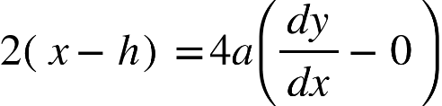

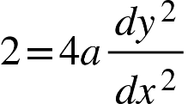

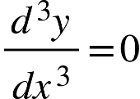 which is the DE

**Find the D.E. of all straight lines whose distance from the origin is unity.**

**Solution:** The equation of a straight line is{"mathml":"<math style=\"font-family:stix;font-size:16px;\" xmlns=\"http://www.w3.org/1998/Math/MathML\"><mo>&#xA0;</mo><mi>y</mi><mo>=</mo><mi>m</mi><mi>x</mi><mo>+</mo><mi>c</mi><mo>.</mo><mo>.</mo><mo>.</mo><mo>.</mo><mo>&#xA0;</mo><mo>(</mo><mn>1</mn><mo>)</mo></math>","origin":"MathType Legacy","version":"v3.18.2"}

Distance from the origin is :

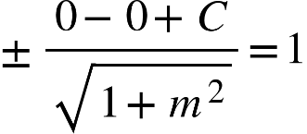

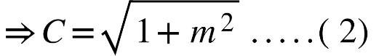

Given that the distance is unity (1), we have: 1=m2+1​∣c∣​ ∣c∣=m2+1​ c=±m2+1​ (2)

From (1) and (2), we get:

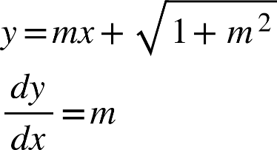​

putting the value of m into (2):

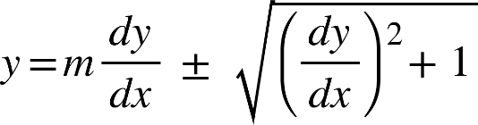

​

which is the required Differential Equation (D.E.).

**EX_5:**

**Find the D.E. of all circles passing through the origin and having their centres on the x-axis.**

**Solution:** The equation of circles passing through the origin and having their centres on the x-axis is:

{"mathml":"<math style=\"font-family:stix;font-size:16px;\" xmlns=\"http://www.w3.org/1998/Math/MathML\"><msup><mi>x</mi><mn>2</mn></msup><mo>+</mo><msup><mi>y</mi><mn>2</mn></msup><mo>+</mo><mn>2</mn><mi>g</mi><mi>x</mi><mo>=</mo><mn>0</mn><mo>.</mo><mo>.</mo><mo>.</mo><mo>.</mo><mo>.</mo><mo>.</mo><mo>.</mo><mo>.</mo><mo>.</mo><mo>(</mo><mn>1</mn><mo>)</mo></math>","origin":"MathType Legacy","version":"v3.18.2"}

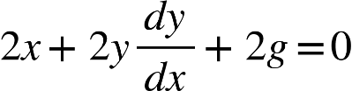

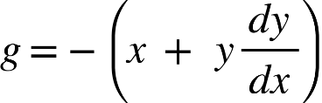

Putting g in 1 ,we get:

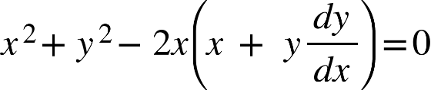

Which is the required D.E.

1. Determine the Differential equation, {"mathml":"<mml:math style=\"font-family:stix;font-size:16px;\" xmlns:m=\"http://schemas.openxmlformats.org/officeDocument/2006/math\" xmlns:mml=\"http://www.w3.org/1998/Math/MathML\"><mml:mstyle mathsize=\"16px\"><mml:mi>y</mml:mi><mml:mo>=</mml:mo><mml:msub><mml:mi>C</mml:mi><mml:mn>1</mml:mn></mml:msub><mml:msup><mml:mi>e</mml:mi><mml:mi>x</mml:mi></mml:msup></mml:mstyle></mml:math>","origin":"MathType Legacy","version":"v3.18.2"}

Solution: 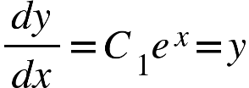

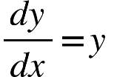

2. Determine the Differential equation, {"mathml":"<mml:math style=\"font-family:stix;font-size:16px;\" xmlns:m=\"http://schemas.openxmlformats.org/officeDocument/2006/math\" xmlns:mml=\"http://www.w3.org/1998/Math/MathML\"><mml:mstyle mathsize=\"16px\"><mml:mi>y</mml:mi><mml:mo>=</mml:mo><mml:msub><mml:mi>C</mml:mi><mml:mn>1</mml:mn></mml:msub><mml:mi>x</mml:mi><mml:mo>+</mml:mo><mml:msub><mml:mi>C</mml:mi><mml:mn>2</mml:mn></mml:msub></mml:mstyle></mml:math>","origin":"MathType Legacy","version":"v3.18.2"}

Solution:

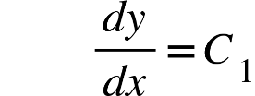

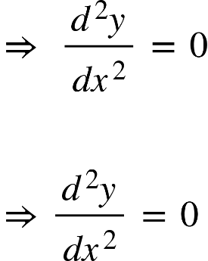

1. Determine the Differential equation, {"mathml":"<math style=\"font-family:stix;font-size:16px;\" xmlns=\"http://www.w3.org/1998/Math/MathML\"><mi>y</mi><mo>&#xA0;</mo><mo>=</mo><mo>&#xA0;</mo><msub><mi>C</mi><mn>1</mn></msub><mo>&#xA0;</mo><mi>cos</mi><mi>x</mi><mo>&#xA0;</mo><mo>+</mo><mo>&#xA0;</mo><msub><mi>C</mi><mn>2</mn></msub><mo>&#xA0;</mo><mi>sin</mi><mi>x</mi></math>","origin":"MathType Legacy","version":"v3.18.2"}

Solution:

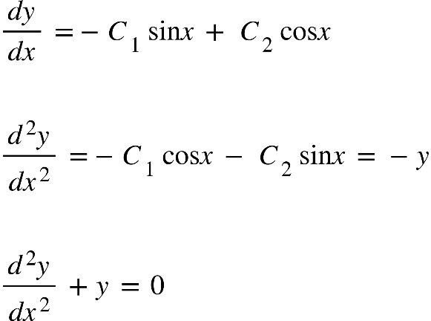

1. Determine the Differential equation, {"mathml":"<math style=\"font-family:stix;font-size:16px;\" xmlns=\"http://www.w3.org/1998/Math/MathML\"><mi>y</mi><mo>&#xA0;</mo><mo>=</mo><mo>&#xA0;</mo><msub><mi>C</mi><mn>1</mn></msub><mo>&#xA0;</mo><msup><mi>e</mi><mrow><mn>2</mn><mi>x</mi></mrow></msup><mo>&#xA0;</mo><mo>+</mo><mo>&#xA0;</mo><msub><mi>C</mi><mn>2</mn></msub><mo>&#xA0;</mo><msup><mi>e</mi><mrow><mo>-</mo><mn>2</mn><mi>x</mi></mrow></msup></math>","origin":"MathType Legacy","version":"v3.18.2"}

Solution:

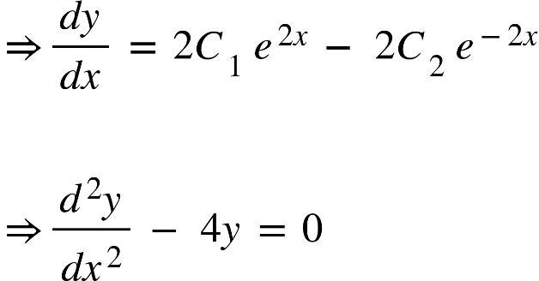

1. Determine the Differential equation, {"mathml":"<math style=\"font-family:stix;font-size:16px;\" xmlns=\"http://www.w3.org/1998/Math/MathML\"><mi>y</mi><mo>&#xA0;</mo><mo>=</mo><mo>&#xA0;</mo><msub><mi>C</mi><mn>1</mn></msub><msup><mi>x</mi><mn>2</mn></msup><mo>&#xA0;</mo><mo>+</mo><mo>&#xA0;</mo><msub><mi>C</mi><mn>2</mn></msub><mo>&#xA0;</mo><mi>x</mi><mo>&#xA0;</mo><mo>+</mo><mo>&#xA0;</mo><mn>3</mn></math>","origin":"MathType Legacy","version":"v3.18.2"}

Solution:

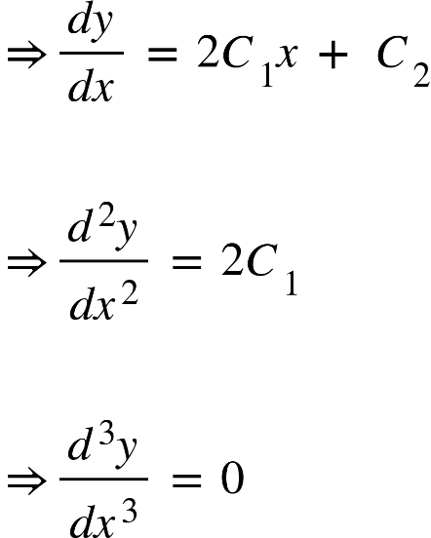

1. Determine the Differential equation, {"mathml":"<math style=\"font-family:stix;font-size:16px;\" xmlns=\"http://www.w3.org/1998/Math/MathML\"><msup><mi>y</mi><mn>2</mn></msup><mo>&#xA0;</mo><mo>=</mo><mo>&#xA0;</mo><msub><mi>C</mi><mn>1</mn></msub><mo>&#xA0;</mo><mi>x</mi><mo>&#xA0;</mo><mo>+</mo><mo>&#xA0;</mo><msub><mi>C</mi><mn>2</mn></msub></math>","origin":"MathType Legacy","version":"v3.18.2"}

Solution:

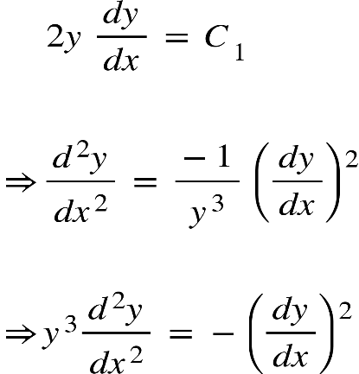

1. Determine the Differential equation, {"mathml":"<math xmlns=\"http://www.w3.org/1998/Math/MathML\" style=\"font-family:stix;font-size:16px;\"><mo>&#xA0;</mo><mo>&#xA0;</mo><mi>y</mi><mo>&#xA0;</mo><mo>=</mo><mo>&#xA0;</mo><mi>a</mi><mo>&#xA0;</mo><mi>ln</mi><mo>&#xA0;</mo><mi>x</mi><mo>&#xA0;</mo><mo>+</mo><mo>&#xA0;</mo><mi>b</mi></math>","origin":"MathType Legacy","version":"v3.18.2"}

Solution:

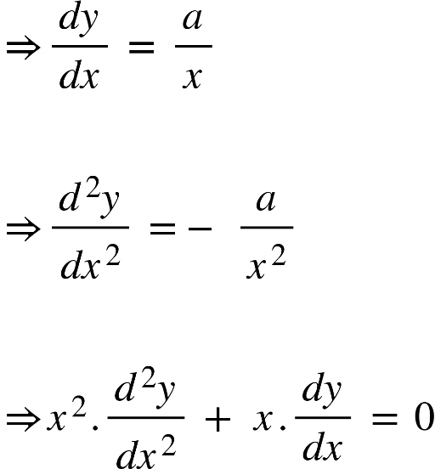

1. Determine the Differential equation, 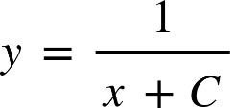

Solution:

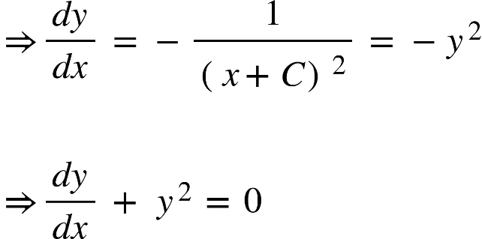

1. Determine the Differential equation, {"mathml":"<math style=\"font-family:stix;font-size:16px;\" xmlns=\"http://www.w3.org/1998/Math/MathML\"><mi>y</mi><mo>&#xA0;</mo><mo>=</mo><mo>&#xA0;</mo><msup><mi>tan</mi><mrow><mo>-</mo><mn>1</mn></mrow></msup><mfenced><mrow><mi>x</mi><mo>+</mo><mi>C</mi></mrow></mfenced></math>","origin":"MathType Legacy","version":"v3.18.2"}

Solution:

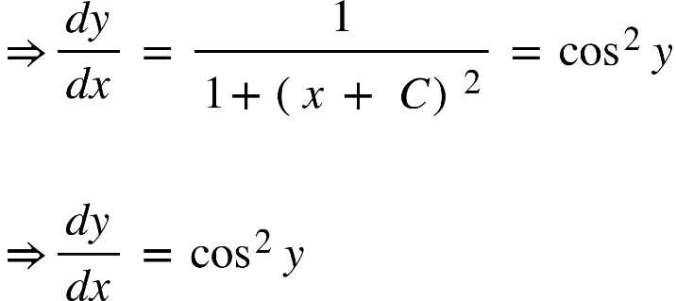

1. Determine the Differential equation, {"mathml":"<math xmlns=\"http://www.w3.org/1998/Math/MathML\" style=\"font-family:stix;font-size:16px;\"><msup><mi>x</mi><mn>2</mn></msup><mo>&#xA0;</mo><mo>+</mo><mo>&#xA0;</mo><msup><mi>y</mi><mn>2</mn></msup><mo>&#xA0;</mo><mo>=</mo><mo>&#xA0;</mo><msup><mi>a</mi><mn>2</mn></msup></math>","origin":"MathType Legacy","version":"v3.18.2"}

Solution:

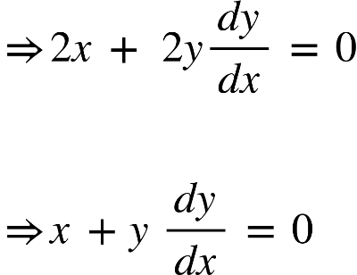

Submitted by:

**MD Esmail Hossen Rohan (240103)**

**MD Mehedi Hasasn(240104)**